Sahithi_Siddamsetty_VT-936.docx
1.
#!/usr/bin/python
import re
s2="I used to have 4563-987-1234,is my phone number,but now i changed it to 567-345-2318,589-574-1258,5874-587-254169"
s1=re.findall(r'\D(\d{3}-\d{3}-\d{4})',s2)
print s1
output:

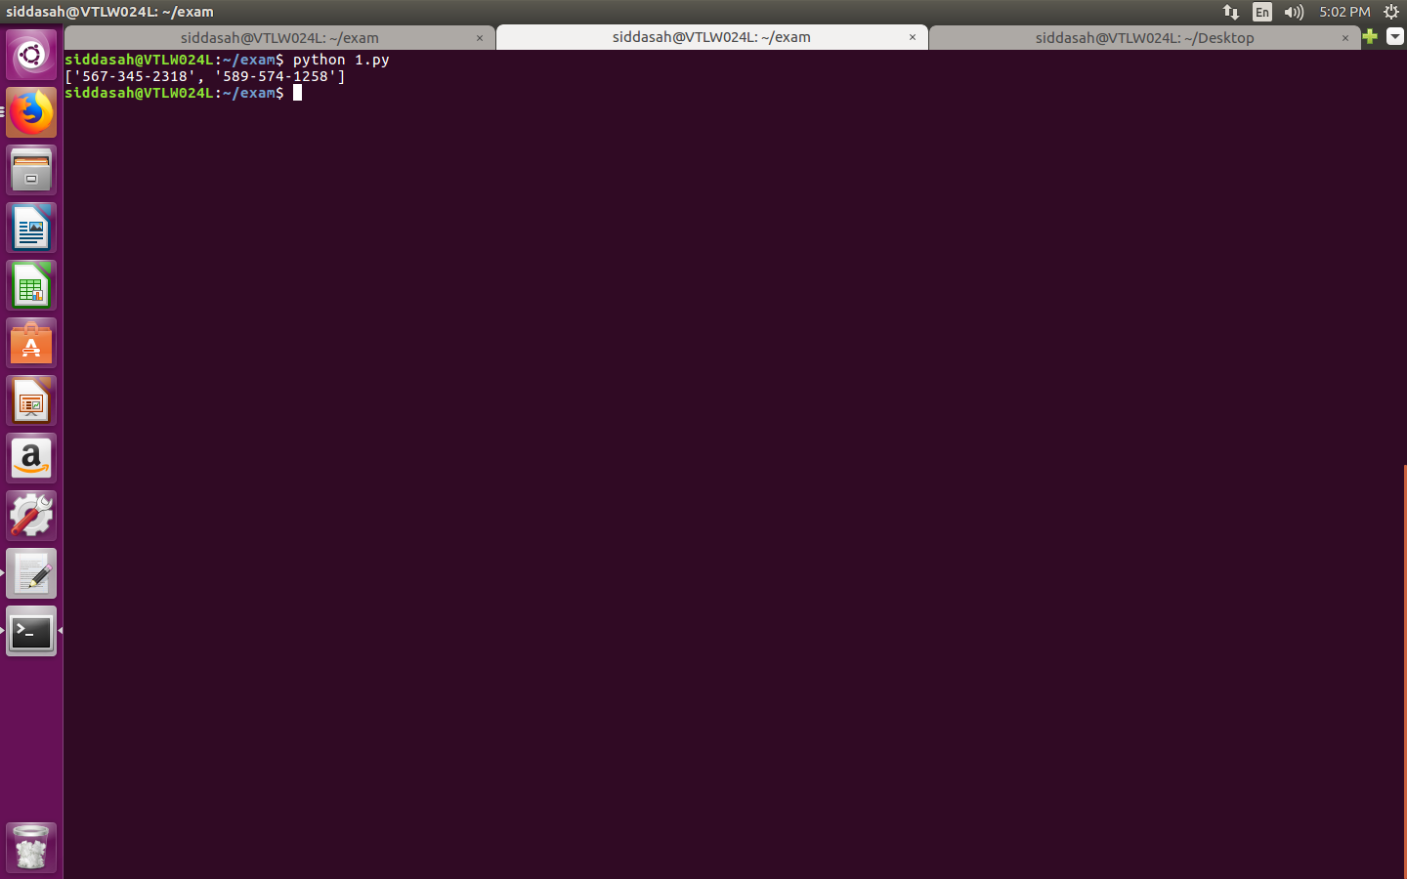
3.

!/usr/bin/python

l1 = [("Ramu", "Python", 99),("Jahnavi", "Django", 100),("Kavya", "Flask", 67),("Bhaskar", "Pyramid", 87)]

print "Descending based on course name::"

x = sorted(l1, key=lambda des: des[1])[::-1]
print x

print "Ascending Based on Marks::"
y = sorted(l1, key=lambda x: x[2])
print y

output:

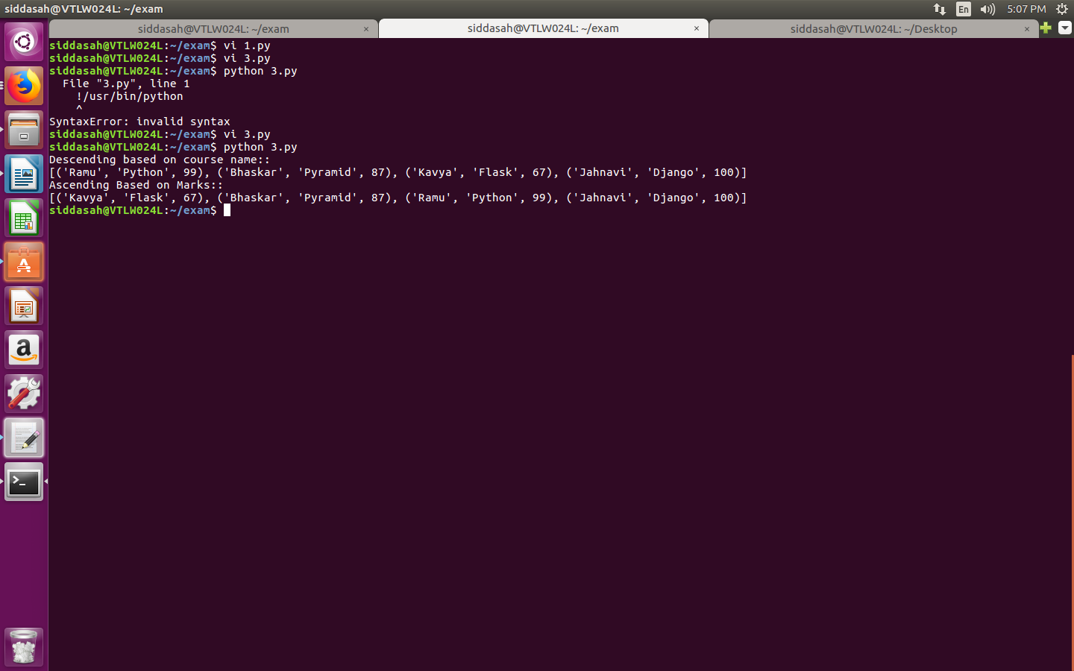

4.

from collections import Counter
from itertools import combinations

l1=['deltas','desalt','lorry','lasted','retainers','salted','areospace','slated','staled','resmelts']
var = combinations(l1,2)
ot=[]
for val in var:
if Counter(val[0])==Counter(val[1]):
ot.extend(list(val))
print(list(set(ot)))

output:

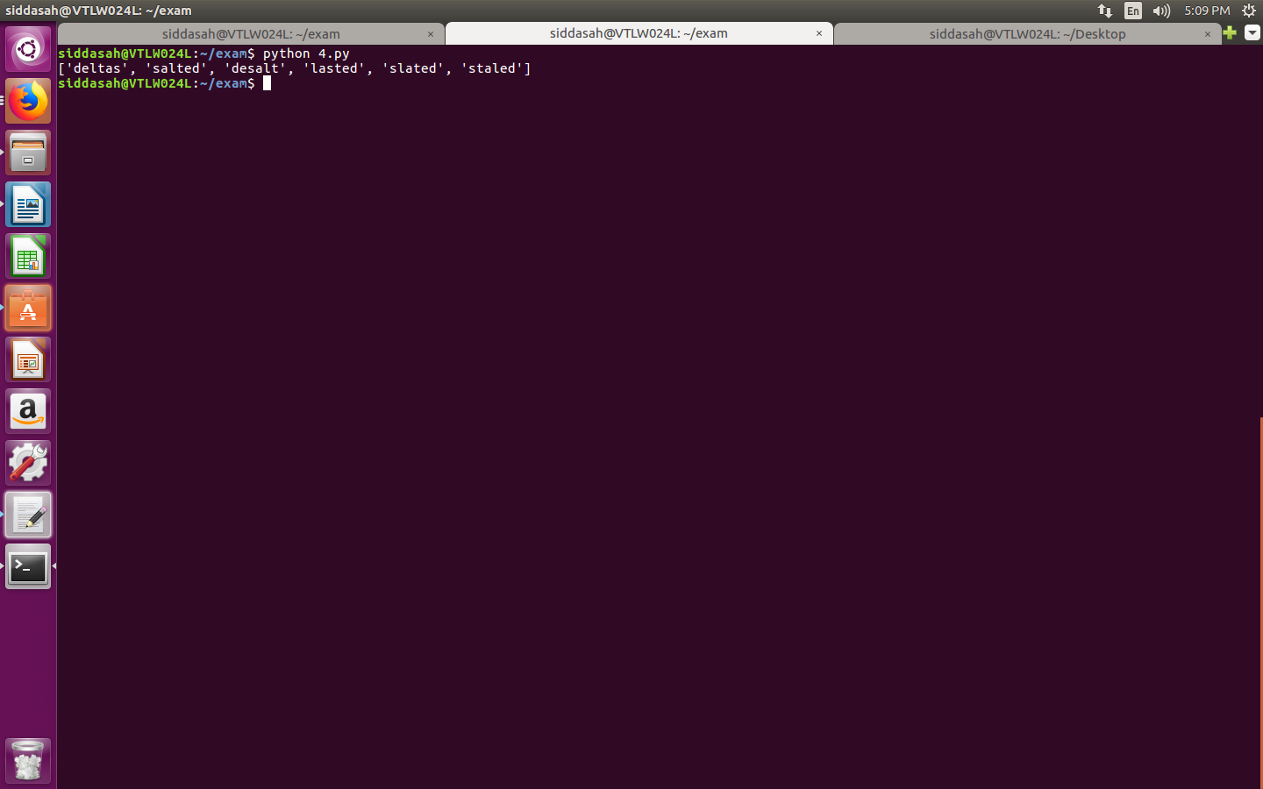

5.

#!/usr/bin/python
l=[]
l1=[]
with open("file1.txt","r+") as f1:
f2=f1.read().split()
for val in f2:
l.append(val)
with open("file2.txt","r+") as f3:
f4=f3.read().split()
for val in f4:
l1.append(val)
for v in l:
for v1 in l1:
if (v==v1):
break
else:
print v
output:

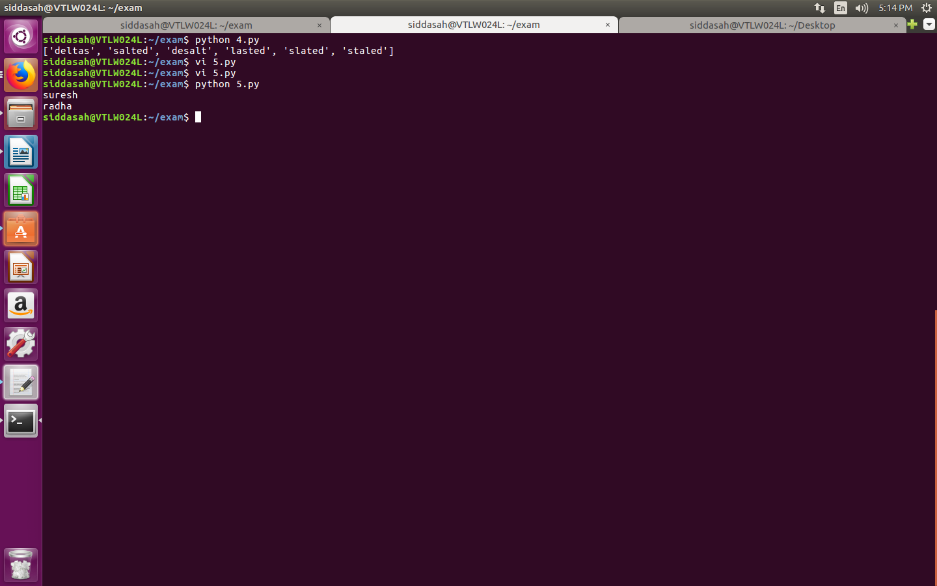

6.
import urllib2
import xml.etree.ElementTree as ET

url = "https://www.w3schools.com/xml/cd_catalog.xml"
data = urllib2.urlopen(url)

with open("cd_catalog.xml", "wb+") as f_obj:
for line in data:
f_obj.write(line)

tree = ET.parse('cd_catalog.xml')
root = tree.getroot()

for child in root:
if child.find('COUNTRY').text == "USA":
print(child.find("TITLE").text)

output:

